SCREEN SHOTS
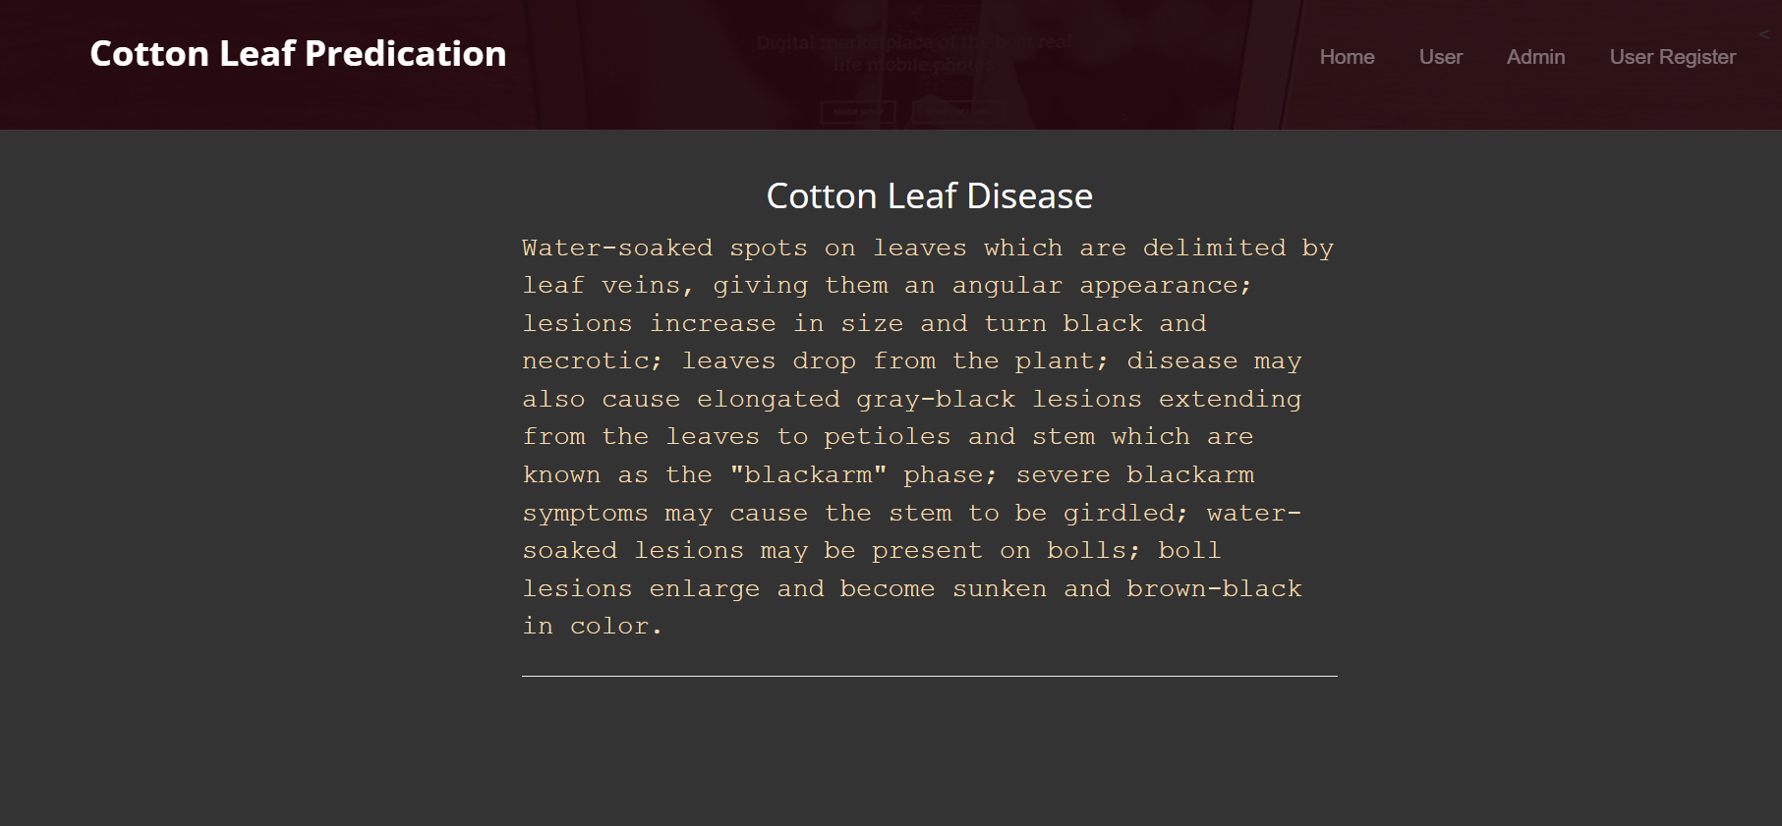
HOMEPAGE

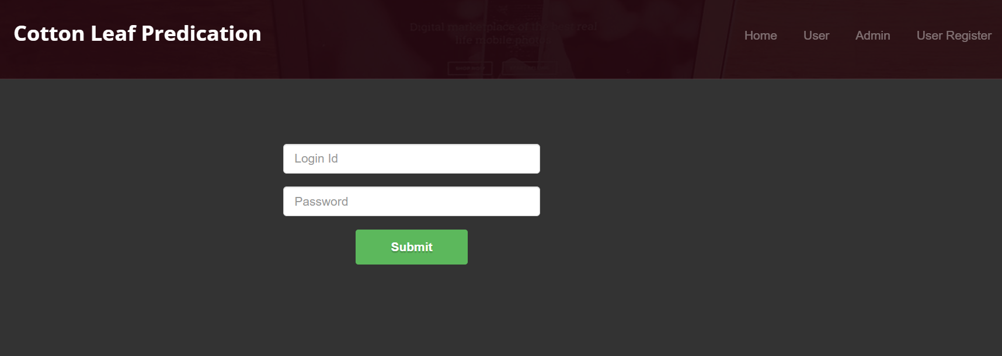
USER LOGIN PAGE

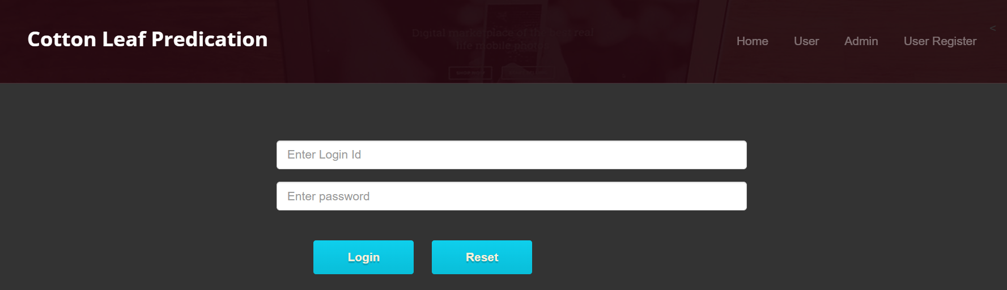
ADMIN LOGIN PAGE

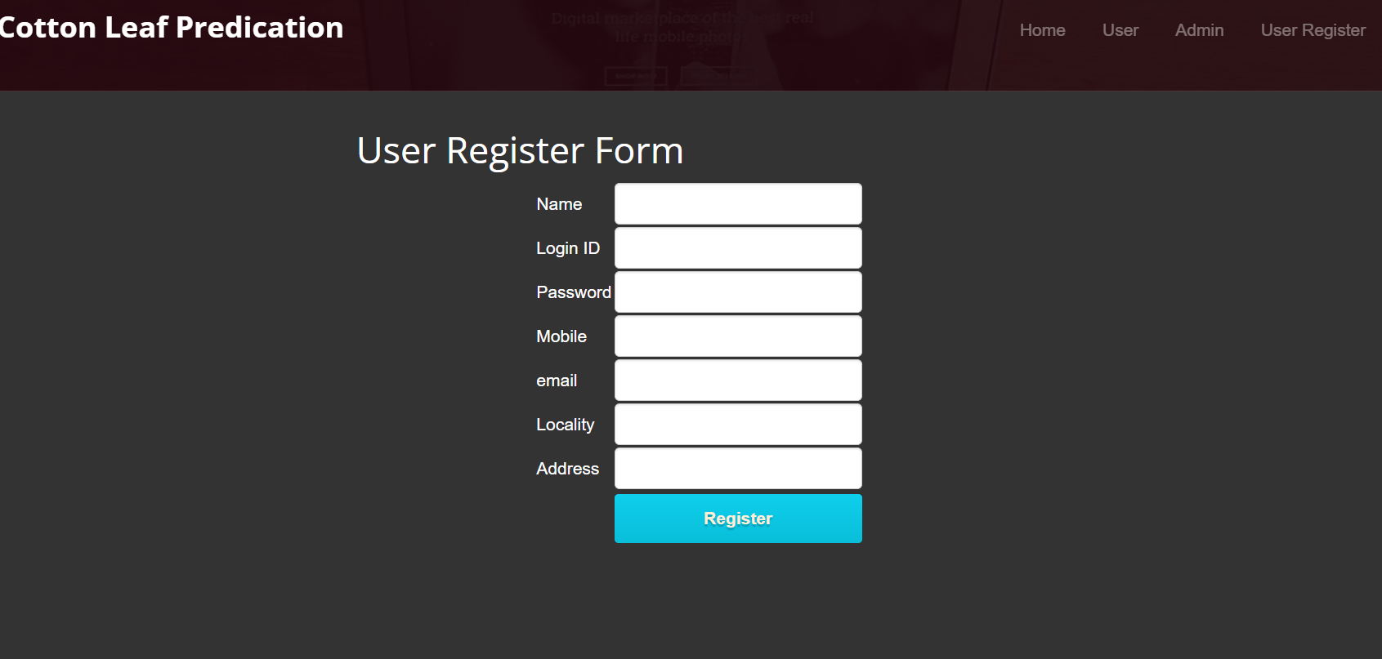USER REGISTER PAGE

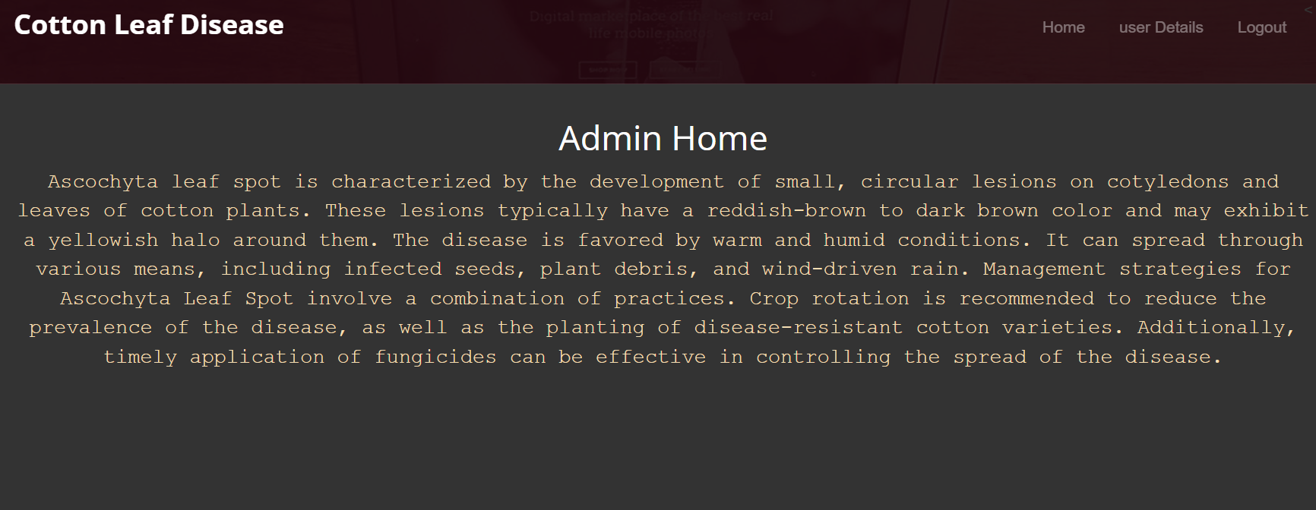
ADMIN HOME PAGE

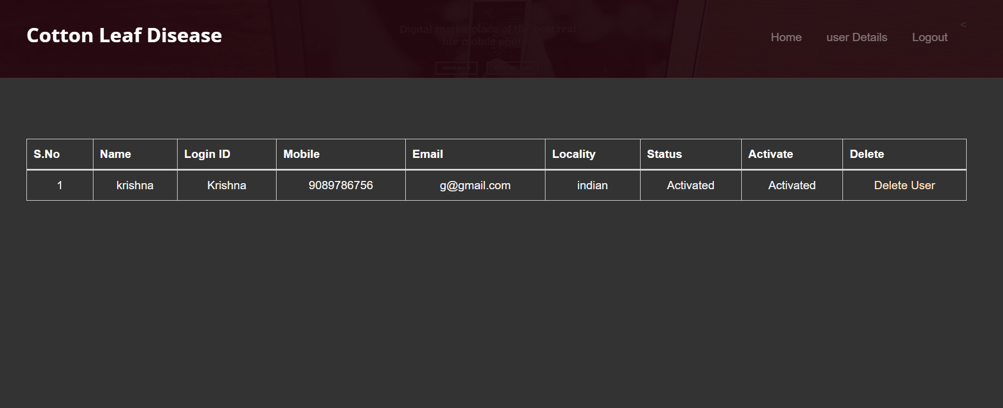
USER DETAILS PAGE

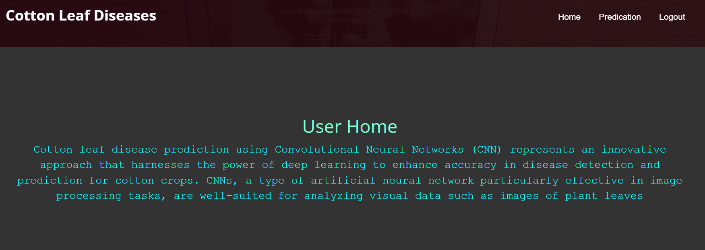
USER HOME PAGE


PREDICATION PAGE

